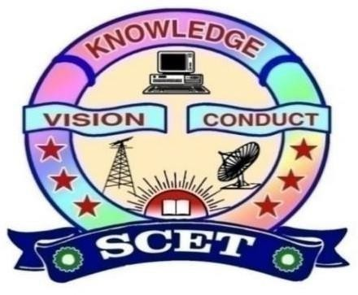
DETECTING CAR SPEED USING OBJECT DETECTION

A Project Report Submitted to

Swarnandhra College of Engineering and Technology
(Autonomous)
In partial fulfillment of the requirements for the award of the degree
MASTER OF COMPUTER APPLICATIONS
By

ALLADA TEJA VENKATA RAJU

(24A21F0072)
Under the guidance of

Mr. A.N.L. KUMAR

Associate professor

DEPARTMENT OF MASTER OF COMPUTER APPLICATIONS

SWARNANDHRA COLLEGE OF ENGINEERING AND TECHNOLOGY
(AUTONOMOUS)
(Approved by AICTE & Permanently Affiliated to JNTUK)(Accredited by NAAC with “A” Grade) SEETHARAMPURAM, NARASAPUR-534280
2024-2026


DEPARTMENT OF MASTER OF COMPUTER APPLICATIONS

SWARNANDHRA COLLEGE OF ENGINEERING AND TECHNOLOGY (AUTONOMUS)
Seetharampuram, Narasapur-534 280.

CERTIFICATE

This is to certify that this project work entitled “DETECTING CAR SPEED USING OBJECT DETECTION” is the Bonafide work of MR. ALLADA TEJA VENKATA RAJU who carried out the work under my supervision, and submitted in partial fulfillment of the requirements for the award of the degree, Master of Computer Applications, during the academic year 2024- 2026.

Project Supervisor Head of Department
Dr.B.GOHIN Mr. A.N.L. KUMAR
Associate Professor Head, Department of MCA

Submitted for the Project Thesis/Dissertation Viva-voice held on………………

External Examiner

DECLARATION

I certify that

The work contained in the project work is original and has been done by me under the guidance of my supervisor. The work has not been submitted to any other University for the award of any degree or diploma. The guidelines of the University are followed in writing this report.

Date: ALLADA TEJA VENKATA RAJU
(24A21F0072)

ACKNOWLEDGEMENT

I extend my heartfelt gratitude to the Almighty for giving me strength in proceeding with this project title “DETECTING CAR SPEED USING OBJECT DETECTION”.

I express my heartfelt gratitude to my parents for supporting me in all the ways in every walk of my life.

I express my sincere thanks to Honorable Sri. K.V. Satyanarayana, Chairman of our college for making necessary arrangement for doing the project.

I wish to express my gratitude to Dr. S. Suresh Kumar, principal of our college, for giving us permission to carry out this project.

I express my sincere thanks to Mr. A.N.L. Kumar, Head, Department of MCA for his learned suggestions and encouragement which made this project a successful one.

I convey my sincere thanks to my project guide Mr. A.N.L. Kumar, Associate Professor, Department of MCA for his learned suggestions and encouragement which made this project a success.

I express my sincere thanks of all the faculty members of our Department of MCA for their valuable support throughout this project work.

I wish to express my thanks to my friends for their enthusiasm, support and encouragement for the completion of this project.

ALLADA TEJA VENKATA RAJU
Regd. No: 24A21F0072

DETECTING CAR SPEED USING OBJECTS DETECTION

ALLADA TEJA VENKATA RAJU
Regd. No: 24A21F0072

ABSTRACT

The ability to accurately detect and monitor vehicle speed is crucial for traffic management, road safety, and law enforcement. In this study, we propose an innovative approach to detecting car speed using object detection techniques. The methodology leverages advanced machine learning algorithms, specifically Convolutional Neural Networks (CNNs), to identify vehicles in real-time from video or image data captured by cameras. By combining object detection with motion tracking, we estimate the speed of vehicles based on their displacement over time. The system is designed to operate in diverse road conditions, including varying lighting, traffic densities, and weather conditions. Through testing on both urban and highway settings, the results demonstrate that the proposed approach can provide accurate and reliable speed measurements. This system could serve as a valuable tool for traffic monitoring systems, automated speed enforcement, and driving behaviour analysis. The proposed solution aims to improve road safety, reduce traffic violations, and optimize traffic flow by providing real-time speed detection capabilities.

INDEX

S.NO | Topic | Page Number
1. | Introduction
2. | Literature Survey
3. | System Analysis
4. | Software Requirement and Specification Document
5. | Use Case Diagram
6. | Exploratory Data Analysis
7. | Data Set Description
8. | Design
9. | UML Diagrams
10. | DL Algorithms
11. | Code
12. | DL Model Accuracy Techniques
13. | Output Screens

